Available for hire:
Finish Line Clock – Seiko ST-306 (with stand)

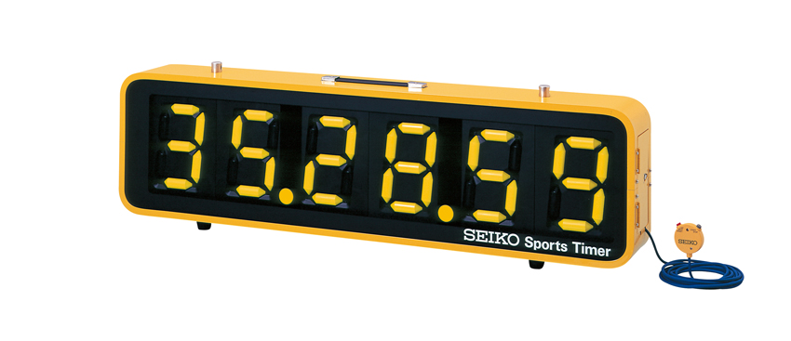
Suitable for cross country and endurance events
Hire Charge £25 per day

Date of Event | Click or tap to enter a date.
Length of Event (Days) | Click or tap here to enter text.
Club | Click or tap here to enter text.
Tick if SCAA Affiliated | ☐
Venue | Click or tap here to enter text.
Contact Name | Click or tap here to enter text.
Email | Click or tap here to enter text.
Telephone | Click or tap here to enter text.

Email completed request form to: pf@surreyathletics.uk

